Software Requirements Specification

For

Play, Learn & Protect: Technology for Childhood & Youth

**Version 1.0 approved**

**Prepared by Ibrahim Moataz , Ali Alaa , Aly waleed , yehia elbably , hamza bakr , Ibrahim Darwish ,Youssef Abdelmalak , mazen gamal**

**GIU**

**6/12/2025**

Table of Contents

Table of Contents ii

Revision History ii

1. Introduction 1

1.1 Purpose 1

1.2 Document Conventions 1

1.3 Intended Audience and Reading Suggestions 1

1.4 Product Scope 1

1.5 References 1

2. Overall Description 2

2.1 Product Perspective 2

2.2 Product Functions 2

2.3 User Classes and Characteristics 2

2.4 Operating Environment 2

2.5 Design and Implementation Constraints 2

2.6 User Documentation 2

2.7 Assumptions and Dependencies 3

3. External Interface Requirements 3

3.1 User Interfaces 3

3.2 Hardware Interfaces 3

3.3 Software Interfaces 3

3.4 Communications Interfaces 3

4. System Features 4

4.1 System Feature 1 4

4.2 System Feature 2 (and so on) 4

5. Other Nonfunctional Requirements 4

5.1 Performance Requirements 4

5.2 Safety Requirements 5

5.3 Security Requirements 5

5.4 Software Quality Attributes 5

5.5 Business Rules 5

6. Other Requirements 5

Appendix A: Glossary 5

Appendix B: Analysis Models 5

Appendix C: To Be Determined List 6

**1.Introduction**

**1.1 Purpose**

the Software Requirements Specification is designed to document and describe the agreement between the customer and the developer regarding the specification of the software product requested [play,learn & protect]. Its primary purpose is to provide a clear and descriptive statement of user requirements that can be used as a reference in further development of the software system. This document is broken into a number of sections used to logically separate the software requirements into easily referenced parts. This Software Requirements Specification aims to describe the Functionality, External Interfaces, Attributes and Design Constraints imposed on Implementation of the software system described throughout the rest of the document. Throughout the description of the software system, the language and terminology used should unambiguous and consistent throughout the document.

* 1. **Document Conventions**

All requirements are captured using the User Story or diagrams format. All requirements documented in this initial SRS are considered **High Priority** for system delivery, unless explicitly stated otherwise.Key terms and system names (e.g., **Play, Learn & Protect**) are written using bold text for clarity .UML diagrams are used throughout the document to visually represent the system's structure and behavior.

* 1. **Intended Audience and Reading Suggestions**

This SRS is made for several groups of audience :

-For developers to know the detailed functionality , constraints , and acceptance criteria.(suggested readings section : 1,2)

-For project managers and sponsors to know the product scope , design , user classes and dependencies.(suggested readings: section 1,1.4 and 2)

For educational consultants to understand the product functions , characteristics and behavioral monitoring constraints.(suggested reading : section 2.2 , 2.3 )

The most effective reading sequence for any type of audiences is to begin with the high-level context provided in Section 1.0 and 2.0 before diving into the granular details of the specific requirements in Section 3.0.

**1.4 Product Scope**

The **Play, Learn & Protect** software is a digital platform whose primary purpose is to deliver high-quality and safe digital experiences to children and youth across three age brackets: (3-5), (6-8), and (9-12) years old.

The core objectives are:

1. **Impactful Learning:** To use "serious games" to teach curriculum-based subjects so that children can become more interested to play these games while in the same time they are actually learning their subjects in their curriclum without boredom and probably more concentration compared to real teaching classes as children like games and interaction.
2. **Creative Development:** To teach imagination and social skills through collaborative, playful content making them use their imagination and building more and new skills without releasing.
3. **Digital Well-being:** To proactively protect children by monitoring digital behavior (cyberbullying, screen time) and generating instructional safety alerts. As all their interaction while using the platform will be recorded and stored and analysed for making sure their behavior is right .

This platform directly supports the strategic goal of providing culturally relevant and modern educational tools, thereby serving as a foundational technology for childhood development in the local market.

**1.5 References**

Websites used for this SRS : cms , draw.io

**2- Overall Description**

**System Overview** 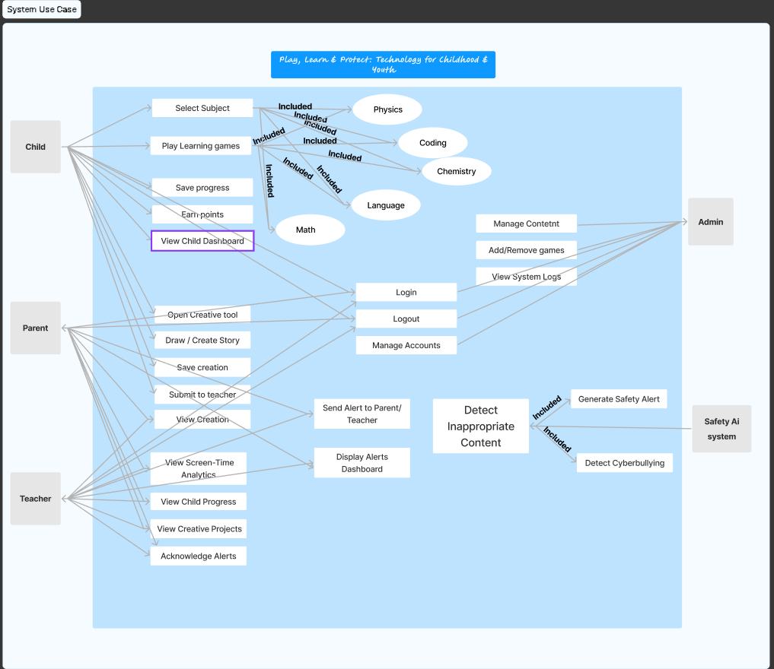

**2.1 Product Perspective**

The **Play, Learn & Protect** system is a newproduct that is not a replacement for a any specific system , or a follow-on to any existing software. It operates as a singular, integrated platform with distinct subsystems that communicate internally:

1. **Core Content System (CCS):** Manages game logic, learning modules, and the creative environment.
2. **User Interface Layer (UI):** Provides the gamified dashboard for children and the analytical dashboards for parents/educators.
3. **Digital Protection Module (DPM):** Handles data logging, behavioral analysis, and alert generation.

The system primarily interfaces with the following external entities: the Child, the Parent , teacher, and the secure cloud server used for data persistence and authentication.

**2.2 Product Functions**

The platform provides functionality across three main pillars:

* **Learning & Play:**

Allowing the Child to play curriculum-based s games (Math, Physics, Coding) . Allowing the Child to use a creative context module to apply learned knowledge . Providing a **gamified** child dashboard with points, achievements, and real-time leaderboards so that child is more interacted and invested in using the platform to play and learn at the same time.

* **Protection & Safety:**

Continuously logging and analyzing the Child's screen time, content accessed, and session frequency . Running background algorithms to detect and flag online threats like cyberbullying or explicit content or using swear words  
.Generating proactive, teaching-focused safety alerts directly to the Child when a threat is identified.all to maintain the childs behavior.

* **Monitoring & Feedback (Parent/Educator):**

Providing secure, detailed monitoring dashboards to view digital behavior patterns.Delivering immediate, actionable alerts to Parents/Educators regarding flagged behavior.Allowing Parents/Educators to view the Child's learning progress, achievements, and creative output and to also track his behavior and check the alerts.

**2.3 User Classes and Characteristics**

The system can have any user who is familiar with using a computer and has internet connection and web browser assuming the user know how to use a computer and a mouse. But mainly its for children age 3-12 years , educators , and parents.

**2.4 Operating Environment**

The software is designed for operation in any web browser.

**Client Devices:** The interface must be fully responsive and functional across major operating systems and devices (iOS, Android, Windows) accessed via standard web browsers.

**Operating System/Browser:** Latest releases of Chrome, Safari, and Firefox.

**2.5 Design and Implementation Constraints**

1. **Cultural Constraints:** The content and the design must be suitable for the culture that’s going to use the platform. The platform must adhere to the cultures language and constraints
2. **Data Privacy:** All data collection regarding the child's activity must be acceptable with strict privacy policies and laws, specifically limiting data logging only to what is necessary for.
3. **Performance:** The serious games module must achieve a minimum user-perceived load time of under 3 seconds and maintain interactivity at all times as children can have low attention span.

**2.6 User Documentation**

The delivered software will include the following user documentation components:

* **Platform Tutorials :** Interactive, optional tutorials embedded within the serious games to explain rules, physics, and creative tool usage.
* **Online Help Center (Parent/Educator):** A comprehensive, searchable digital manual accessible via the monitoring dashboard detailing features, alert interpretation, and troubleshooting.
* **"How-To" Video Guides:** Short video tutorials demonstrating key tasks like setting screen limits and viewing progress.
  1. **Assumptions and Dependencies**

**Assumptions :**Its assumed that curriculum content outlines and culturally relevant artistic assets like character designs and historical elements will be provided by subject Teachers. Its also assumed that Content is to be educationally sound and age-appropriate upon initial design and review by the project's educational consultant.

**Dependencies:** Firebase Authentication & Firestore: The entire system relies on the functionality of Firebase for user management and real-time data storage and External API Access for Potential future dependencies on external APIs like Gemini API for advanced content or natural language processing for enhanced safety or learning features.

**3- External Interface Requirements**

#### **User Interfaces**

The system shall provide user-friendly, iteractive, and gamified interfaces accessible to children, teachers, and parents. Key interface features include: Dashboards for monitoring progress, achievements, and points.Interactive modules for learning currciclum courses.Visual feedback for earned awards, leaderboards, and competitions.Notifications and alerts for digital safety incidents and monitoring of children behavior.

**Hardware Interfaces**

The system shall support interaction with standard consumer devices, including:Tablets and smartphones running Android or iOS . Desktop/laptop computers running Windows, macOS, or Linux . Input devices such as keyboard, mouse, and touchscreens . Internet connectivity for real-time data synchronization and updates.

#### **3.3 Software Interfaces**

The system shall interface with the following software components:

-Web browsers (Chrome, Edge, Safari) for web-based access.

-Mobile OS SDKs for Android and iOS apps.

-Backend services for data storage, analytics, and user management.

#### **3.4 Communications Interfaces**

The system shall utilize standard communication protocols to ensure secure and efficient data transfer:

* HTTPS/REST APIs for client-server communication.
* WebSocket protocols for real-time notifications and alerts.
* Email and push notifications for parental alerts.
* Secure data transmission following encryption standards (TLS 1.2 or higher).

**4- System Features**

This section organizes the detailed functional requirements by the major services, or features, the **Play, Learn & Protect** platform offers.

**4.1 Digital Protection Module (DPM)**

This feature encompasses all capabilities related to monitoring the child's online activity, identifying potential risks, and generating safety alerts for both the child and the supervising adult.

**4.1.1 Description and Priority**

The DPM is the core safety component of the system. It operates passively in the background, logging activity and applying proprietary algorithms to detect digital threats, including but not limited to cyberbullying, exposure to inappropriate content, and patterns indicative of excessive gaming. The primary goal is to **educate** the child on safe digital behavior, rather than simply block content.

* **Priority:** **High** (This feature is central to the "Protect" mandate of the project and addresses a critical societal need.)
* **Risk:** High (False positive alerts could erode user trust; algorithms require extensive tuning and validation.)

**4.1.2 Stimulus/Response Sequences**

|  |  |
| --- | --- |
| **Stimulus (User Action/System Event)** | **Response (System Behavior)** |
| Child enters text into the in-game chat/comment section containing a flagged keyword (e.g., bullying language). | The DPM processes the text, flags the interaction, and initiates the Alert Generation sequence. |
| Child session duration exceeds the pre-set parental time limit by 15 minutes. | The DPM triggers a soft, in-game notification to the child asking them to take a break, and updates the Parent/Educator Dashboard. |
| Parent/Educator logs into the monitoring dashboard. | The system retrieves and displays the child’s aggregated digital activity data (screen time, content history) in real-time charts. |
| Parent/Educator clicks the "Acknowledge" button on a safety alert notification. | The system records the acknowledgment timestamp and moves the alert to the history log, removing it from the active alerts list. |

**4.1.3 Functional Requirements**

The following functional requirements detail the capabilities for the Digital Protection Module:

**REQ-DPM-1(req1): Real-Time Activity Logging**

The system shall continuously and non-intrusively log the Child's session start/end times, content accessed (game title/module name), and total time spent in each session.

**Acceptance criteria:** The system is accepted if it accurately and non-intrusively records the start and end times and duration for every session, along with the specific content title accessed. The logging must be continuous, meaning data persisted even if the application crashes or the network connection is lost.

**REQ-DPM-2(req2): Threat Detection Algorithm**

The system shall employ a language processing algorithm to analyze user-generated text (e.g., comments, chat) for keywords or patterns associated with cyberbullying, harassment, or explicit content.

**Acceptance criteria:** The algorithm is accepted if it successfully captures and analyzes 100% of user-generated text in near real-time (under 500ms latency), achieving a high True Positive Rate (e.g., >95%) for cyberbullying, harassment, and explicit patterns. Crucially, it must also maintain a low False Positive Rate (e.g., <3%) to avoid flagging benign messages.

**Use Case Diagram for Digital Protection Module**

### **4.2 Gamified Dashboard (REQ-UI-1)**

**Description and Priority**  
 The Gamified Dashboard provides a child-friendly interface to display achievements, points, leaderboards, and awards in real-time. It is designed to motivate engagement and learning by incorporating game-like rewards and progress indicators. This feature enhances the overall user experience by encouraging continued participation.

**Priority:** High (Encourages learning through engagement; central to “Play & Learn” mandate)  
 **Risk:** Medium (Poorly designed dashboards may confuse children or reduce motivation)

**Stimulus/Response Sequences**

|  |  |
| --- | --- |
| **Stimulus (User Action/System Event)** | **Response (System Behavior)** |
| Child completes a learning module successfully | The system updates points, achievements, and awards on the dashboard immediately. |
| Child opens the dashboard | The system displays real-time stats: points, leaderboard position, badges, and awards earned. |
| Parent/educator logs into dashboard view | The system presents the child’s progress, achievements, and leaderboard rankings in a visually clear manner. |
| Child earns a new badge or unlocks an award | The system triggers an animated notification on the dashboard to celebrate achievement. |

**Functional Requirements**

* **REQ-UI-1(req3):** The system shall provide a child-friendly dashboard that displays achievements, points, leaderboards, and awards in real-time to motivate engagement and learning.

# Detailed Specifications

### **1. Dashboard Display**

The system shall provide a child-friendly dashboard showing: Points , Achievements & badges , Awards , Leaderboard position and all values must update in real time whenever progress is made.

### **2. Child-Friendly Design**

The dashboard shall use simple visuals, large icons, and easy navigation suitable for children aged **3–12**.

### **3. Parent/Educator View**

The system shall present a modified dashboard for parents/educators showing: Child progress , Recent achievements , Leaderboard ranking.

**4 - Acceptance Criteria;**

-Verifythat the dashboard interface is simple, visually child-friendly, and appropriate for the platform’s age groups (3–5, 6–8, 9–12) as required in the project brief .

-Verify that the dashboard displays all mandatory gamified elements: points, achievements, badges/awards, leaderboard, and competitions (where implemented) as stated in the proposal .

**Activity Diagram**

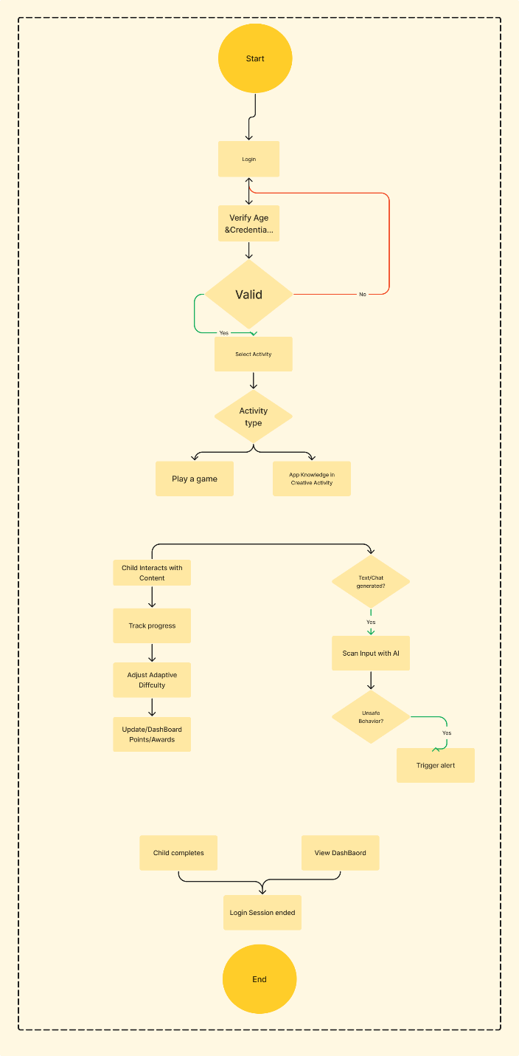

### **4.2.2 Curriculum-Based Learning Modules (REQ-LRN-1)**

**Description and Priority**  
 These modules offer interactive, curriculum-based learning experiences in subjects such as math, science, language, and coding. The system tracks the child’s progress and adapts difficulty based on performance to ensure effective learning outcomes.

**Priority:** High (Core component of the “Learn” mandate)  
**Risk:** Medium (Adaptive algorithms may misjudge difficulty or progression without proper tuning)

**Stimulus/Response Sequences**

|  |  |
| --- | --- |
| **Stimulus (User Action/System Event)** | **Response (System Behavior)** |
| Child starts a learning module | The system presents interactive content with adaptive difficulty based on prior performance. |
| Child answers a question correctly | The system updates progress tracking, awards points, and may adjust difficulty upwards. |
| Child answers a question incorrectly | The system provides hints, feedback, and adjusts difficulty or review material. |
| Parent/educator views module progress | The system displays completion status, scores, and adaptive recommendations in a dashboard view. |

**Functional Requirements**

* **REQ-LRN-1(req 4):** The system shall offer interactive learning modules covering subjects such as math, science, language, and coding, with progress tracking and adaptive difficulty based on the child’s performance.

# **Detailed Specifications:**

### **1. Interactive Learning Modules**

The system shall provide curriculum-based modules in: Math , Science , Language , Coding and each module must present interactive questions, activities, and guided tasks

### **2. Progress Tracking**

The system shall track: Correct/incorrect responses , Completion status , Time spent , Module scores and progress data must be stored per child and updated in real time.

### **3. Adaptive Difficulty**

The system shall automatically adjust difficulty based on performance: Increase difficulty after consistent correct answers , Reduce difficulty or provide review content after incorrect answers , Offer hints or feedback when needed

# **4- Acceptance Criteria**

# - Verify that modules provide interactive learning content for math, science, language, and coding as required in the project brief .

-Verify that difficulty increases after correct answers and decreases or provides review/hints after incorrect answers.

**Sequence Diagram**

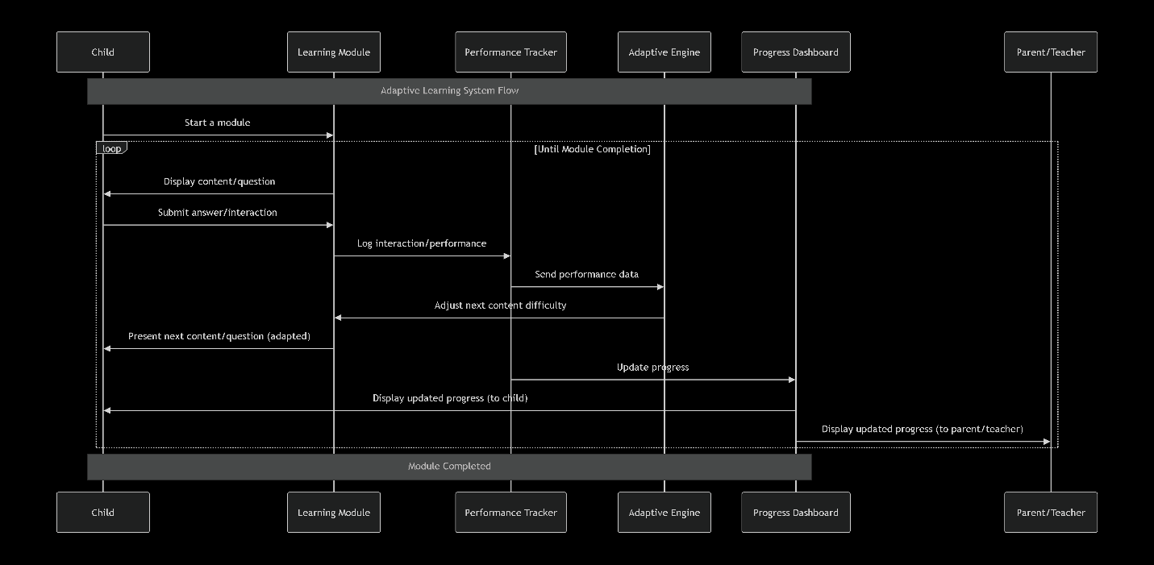

**4.3 Creative Application Studio (REQ-CRE-1)**

**Description and Priority**  
This feature addresses the project requirement that children must be able to apply knowledge learned in a creative context. It allows users to transition from "serious games" to a "studio" mode where they can use open-ended tools (drawing, building, storytelling) related to the curriculum (e.g. using physics concepts to build a structure).

**Priority:** High (This is essential to ensure the user feels like they are playing a game, rather than just performing drills. It fulfills our core 'Play' requirement).

**Risk:** High (Complexity in creating open-ended tools that are intuitive for 3–5-year-olds).

**Stimulus/Response Sequences:**

|  |  |
| --- | --- |
| **Stimulus (User Action/System Event)** | **Response (System Behavior)** |
| Child selects "Create Mode" after a Physics lesson | The system loads the Creative Studio with specific tools unlocked (e.g. gravity, blocks) relevant to the lesson |
| Child attempts to save their creative project | The system validates the content, saves the project to the user profile, and awards "Creativity Points" |
| Child selects "Share with Teacher" | The system changes the project state to "Submitted" and notifies the linked educator account |
| Child attempts to use a tool they haven't unlocked yet | The system displays a prompt encouraging the child to play specific learning games to unlock the tool |

**Functional Requirements**

**REQ-CRE-1(req5):** The system shall provide a Creative Application Studio that allows children to utilize digital tools to create artifacts (stories, drawings, structures) applying concepts learned in curriculum modules, with capabilities to save, edit, and share work with educators.

**Acceptance Criteria;**

- Verify that specific creative tools (e.g. physics modifiers) become usable only after the child completes the corresponding educational module.

-Verify that the system successfully saves, retrieves, and reconstructs a user’s creative workspace state (including object positions and properties) across login sessions

**WRSPM Model**

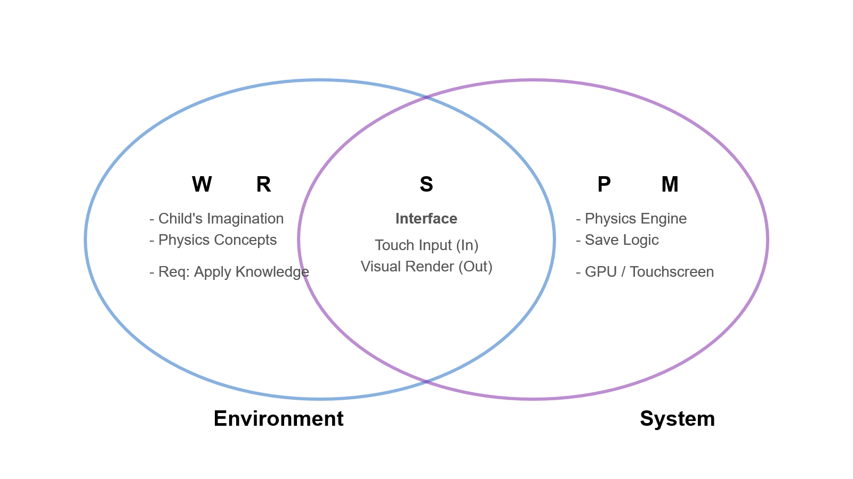

**4.3.2 Parental Analytics & Visualization (REQ-ANL-1)**

**Description and Priority**  
While the Digital Protection Module (4.1) handles *logging* and *alerts*, this feature specifically addresses the requirement for Dashboards that visualize time spent, types of content accessed, and frequency of sessions. This feature processes raw logs into readable, graphical insights for parents and educators to observe screen-time patterns.

**Priority:** Medium (Critical for the "Protect" aspect, specifically for adult supervision, though the system can function without the *visualization* layer initially).

**Risk:** Low (Standard data visualization task, though data privacy regarding what specific details are shown to teachers vs parents must be handled carefully).

**Stimulus/Response Sequences:**

|  |  |
| --- | --- |
| **Stimulus (User Action/System Event)** | **Response (System Behavior)** |
| Parent selects the "Screen Time" tab on the dashboard | The system queries the database and renders a bar chart showing daily usage hours over the last 7 days |
| Educator filters the class view by "At-Risk Behavior" | The system identifies students with flagged screen-time patterns and highlights them in the list |
| Parent clicks on a specific session in the history log | The system expands the view to show the specific games played and learning objectives covered during that session |
| A weekly cycle concludes (e.g. Saturday night) | The system automatically generates a "Weekly Summary" report and pushes a notification to the Parent |

**Functional Requirements**

**REQ-ANL-1(req 6):** The system shall generate visual analytics dashboards for Parents and Educators that display aggregated data regarding screen time, session frequency, and content categorization, allowing for date-range filtering and trend analysis.

**Acceptance Criteria :**

- Verify that the dashboard visualizations accurately reflect logged database entries, clearly separating "Serious Game" playtime from "Creative Studio" usage.

- Verify that any session containing flagged keywords (cyberbullying / inappropriate content) is visually distinct (e.g. color-coded) on the timeline to alert the supervisor immediately.

**

### **4.4.1 User Registration & Role Management**

Description and Priority

This feature manages the secure creation of user accounts and the critical linkage between Parent and Child profiles. It ensures that children cannot create accounts without parental consent, satisfying the safety constraints of the project scope.

* **Priority:** High (Prerequisite for all other features; System cannot function without users).
* **Risk:** High (Improper role assignment could allow children to bypass safety controls).

**Stimulus/Response Sequences**

|  |  |
| --- | --- |
| **Stimulus (User Action/System Event)** | **Response (System Behavior)** |
| Parent registers a new account | The system sends a verification email and initializes a "Guardian" profile. |
| Parent selects "Add Child" | The system prompts for Child details (Age, Name) and generates a unique linkage ID. |
| Child attempts to login | The system verifies the credentials against the linked Parent account status. |

**User Story REQ-ACC-1(req7):**As a **Parent**, I want to **create and link a child account to my own profile**, so that **I can manage their settings and ensure they only access age-appropriate content.**

**Detailed Specifications**

1. **Authentication:** The system shall use Firebase Authentication to handle secure email/password and social logins (Google/Facebook).
2. **Role Assignment:** Upon registration, the system shall force a role selection: Guardian (Full Access) or Educator (Class Access). Child accounts can *only* be created by an active Guardian account.
3. **Data Linkage:** The database shall store a parent_id foreign key within the Child user document to enforce the monitoring relationship.

**Acceptance Criteria**

-Verify that a Child account cannot be created without a linked Parent account.

-Verify that deleting a Parent account suspends all linked Child accounts.

- Verify that users strictly adhere to the age-groups (3-5, 6-8, 9-12) during setup.

**WRSPM Model for REQ-ACC-1**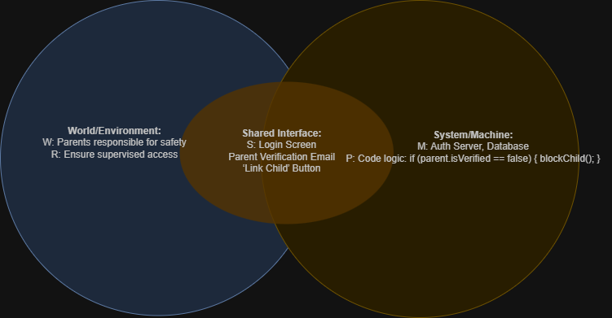

State Machine Diagram

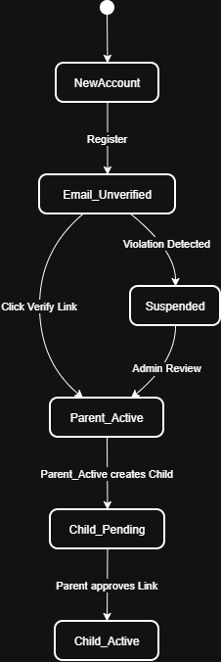

### **4.4.2 Teacher Class Management**

Description and Priority

This feature allows Educators to group students into "Classes" to streamline game assignments and progress tracking. It fulfills the "Impactful Learning" objective by allowing organized curriculum delivery.

* **Priority:** Medium (Essential for the "Learn" mandate in school settings).
* **Risk:** Low (Standard database relationship management).

**Stimulus/Response Sequences**

|  |  |
| --- | --- |
| **Stimulus (User Action/System Event)** | **Response (System Behavior)** |
| Teacher creates a "Class Group" | The system generates a unique 6-digit "Class Code". |
| Parent enters "Class Code" in Child profile | The system links the Child to the Teacher's roster for monitoring. |
| Teacher assigns a game to the Class | The system pushes a notification to all linked Child dashboards. |

**REQ-TCH-1(req8):**As a **Teacher**, I want to **group student accounts into a Class roster**, so that **I can assign specific homework games to everyone at once.**

**Detailed Specifications**

1. **Group Generation:** The system shall allow Educator users to create ClassGroup objects containing a list of studentIDs and a shared curriculumLevel.
2. **Assignment Logic:** When a game is assigned to a Class, the system shall write a reference ID to the pendingTasks array of every student in that group.
3. **Privacy:** Teachers shall only see data related to *academic progress* (scores, completion), not the *behavioral safety logs* (which are private to Parents).

**Acceptance Criteria**

-Verify that a "Class Code" successfully links a Student to a Teacher.

- Verify that Teachers **cannot** view a student's private chat logs or safety alerts (Privacy Constraint).

- Verify that assigning a game updates the dashboard of all 30+ students in a class simultaneously.

Class Diagram

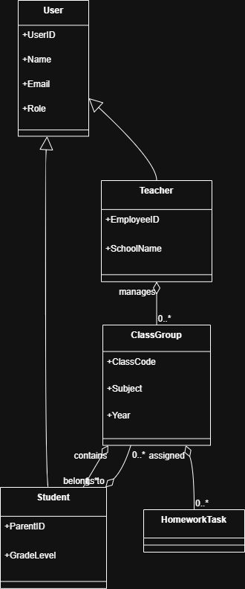

### **4.5.1 Educational Safety Alerts**

#### **Description and Priority**

This feature addresses the pedagogical requirement that the system must not simply block threats, but actively teach the child why certain behaviors are unsafe . When the Digital Protection Module flags a risk, this feature intervenes with an age-appropriate educational overlay.

* **Priority:** High (Critical for the "Protect" mandate and differentiating the product from standard firewalls).
* **Risk:** Medium (The language used in alerts must be carefully calibrated to be instructive without being overly frightening for the 3-5 age group).

**Stimulus/Response Sequences**

|  |  |
| --- | --- |
| **Stimulus (User Action/System Event)** | **Response (System Behavior)** |
| DPM detects a "High Confidence" threat (e.g., cyberbullying keyword). | The system pauses the current session and displays a full-screen educational overlay explaining the issue. |
| Child clicks "I Understand" on the warning overlay. | The system resumes the session (or closes the chat window) and logs the acknowledgment for the Parent Dashboard. |
| DPM detects a "Low Confidence" threat. | The system displays a small, non-intrusive "Tip Bubble" with a safety reminder (e.g., "Remember to be kind!"). |

**REQ-SAF-1(req9):**As a **Child User**, I want to **receive an explanation if I do something unsafe**, so that **I can learn why it is dangerous instead of just being blocked without knowing why**.

**Acceptance Criteria**

-Verify that a detected threat triggers the alert within 2 seconds.

- Verify that the alert text/audio matches the specific age group of the logged-in user.

- Verify that the session cannot continue until the alert is acknowledged.

**Sequence Diagram (Safety Alert Flow)**

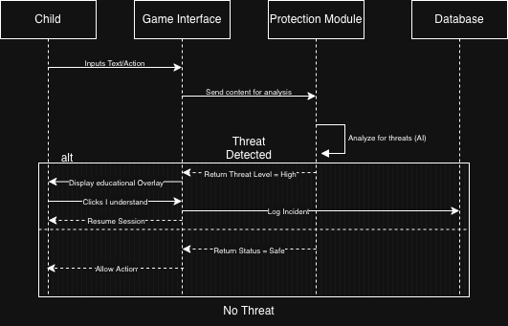

**4.5.2 Competitive Learning Challenges**

#### **Description and Priority**

This feature enables the creation and management of competitions to foster engagement through social motivation . It allows Teachers to set "Challenges" (e.g., "Math Week Sprint") and the system to host automated leaderboard events.

* **Priority**: Medium (Enhances the "Play" and "Learn" pillars but the system is functional without it).
* **Risk**: Low (Standard gamification logic).

**Stimulus/Response Sequences**

|  |  |
| --- | --- |
| **Stimulus (User Action/System Event)** | **Response (System Behavior)** |
| Teacher publishes a "Class Challenge" (e.g., finish 3 Physics modules). | The system sends a "New Challenge!" notification to all students in that Class Roster. |
| Child completes a game included in an active challenge. | The system calculates the score contribution and updates the specific "Challenge Leaderboard" in real-time. |
| The challenge time limit expires. | The system freezes the leaderboard, awards "Trophy" badges to the top 3 users, and sends a summary report to the Teacher. |

**REQ-CMP-1(req 10):** As a **Student**, I want to **compete in game challenges with my classmates**, so that **I can earn special rewards and see how I rank compared to my friends**.

#### **Detailed Specifications**

* The system shall allow **Educator** users to create **Challenge** objects defined by: Start Date, End Date, Specific Game Modules, and Target Score.
* The system shall maintain real-time **Leaderboards** specific to each active challenge, distinct from the global point rankings.
* The system shall automatically distribute virtual awards (Badges/Trophies) to user profiles upon the completion of a challenge based on rank.

#### **Acceptance Criteria**

- Verify that a student only sees challenges assigned to their specific Class ID.

- Verify that points earned *outside* the challenge timeframe do not count toward the challenge leaderboard.

- Verify that the top 3 users automatically receive the correct badge asset in their inventory after the challenge ends.

#### **Class Diagram (Backend Structure for Competitions)**

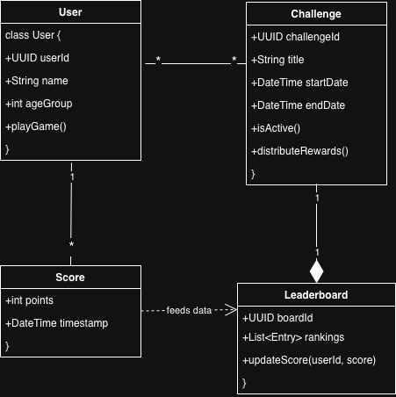

**4.6.1Requirement — Product Functions**

REQ-PFN-1(req11)

This requirement provides core functions of the platform to children,educators & parents, including curriculum based modules of learning.Adding On, it provides creative tools , dashboards for gaming and monitorizing digital behaviour with each function being appropriate for its role.

**Specifications:**

The system loads the appropriate age module depending on the age group the user registered, in other words: 3–5, 6–8, 9–12.. The system

Applies role based access to be able to play games, open dashboards and creative tools for children. Parents also can access the dashboard to be able to monitor their children's behaviour .Also educators can access the class learning progress.

The system also must have a log function usage meaning that there is a digital subsystem that is used for learning modules ,dashboard etc.

The system also must be made to support the different devices a user can use whether a tablet,laptop or mobile.

**Acceptance Criteria**

1.System loads appropriate functions based on user role and age group

2 .Analytics can be viewed by parents, but not child-only game content.

Educators can view Learning and Progress data, not sensitive Safety Alerts Children can access the modules of learning, playing, and creativity without granting any access to the monitoring features.

**4.6.2 Requirement ; Operating Environment**

REQ-ENV-1(req12)

This requirement is a must because we need to define the environment in which a software should run and this allows the cross platforming in mobiles or other devices, thus this provides flexibility in our app while also mainintg the cloud based synchronization.

It is considered a medium priority requirement and its risk is low as it is standard compliance with browser requirements. Detailed Specifications.System should adapt ui layout dynamically to screen size in mobile>tablet>desktop.The system should require a minimum version for browser(for example: chrome 10.1+,firefox v2).The system should also support offline fallback whether in game state caching when user logs out and also storing progress in game on the local device to be able to continue playing later without losing progress. The system also should integrate the firebase auth and firestore because these are essential in the backend.

**Acceptance Criteria:**

phones, tablets, and desktops loads correctly

Browser compatibility test passes in latest Chrome, Firefox

The system continues basic operation at sufficient internet speed . offline progress syncs within 5 seconds of reconnection .

**5 Other Nonfunctional Requirements**

This section describes requirements related to the performance , security , availability , usability ,and safety , as well as software quality attributes and business rules. Each subsection is separated by a set of nonfunctional requirements . They were generated using stakeholder recommended functionality for the system.

**5.1 Performance Requirements**

This section defines the performance-related constraints the system must meet to ensure a smooth and responsive user experience. These requirements specify the expected load times , responsiveness of the interactive components , and overall system speed during normal operation. Performance requirements ensure that children, parents, and educators can access content quickly , without delays that may affect usability or learning engagement. Each performance requirement is listed in Table 5-1.

|  |  |
| --- | --- |
| Requirement ID | Requirement Description |
| REQ-PER-1.1 | The system should recover from a server failure and continue working normally after 40 sec |
| REQ-PER-1.2 | The system should maintain 99% uptime over any 30 days |
| OPT-PER-1.3 | The system may provide a copy of the servers to automatically distribute load during peak usage |
| REQ-PER-1.4 | The interface should be simple for children and adults and easy to navigate without difficulties |
| REQ-PER-1.5 | Parents should be able to view the child activity data in a few clicks (4-5) |
| REQ-PER-1.6 | The system should provide new users with a tutorial to tell them how to use the platform |
| REQ-PER-1.7 | The system shall load all child-related modules(dashboards, learning content,etc) within 3 seconds under normal network conditions. |
| OPT-PER-1.8 | The system may pre-cache commonly used assets(e.g icons, avatars , basic UI components, etc) to reduce loading times during repeated sessions |

**5.2 Safety Requirements**

This section defines requirements that ensure the system operates without causing harm or exposing children to unsafe situations. Safety requirements cover digital safety , error handling , age appropriate warnings , and prevents harmful misuse of system features. Each safety requirement is listed in table 5-5.

Table 5-2: Safety Requirements

|  |  |
| --- | --- |
| Requirement ID | Requirement Description |
| REQ-SAF-2.1 | The system shall prevent children from accessing inappropriate or unverified external links by automatically blocking or filtering them |
| REQ-SAF-2.2 | The system shall display age-appropriate safety warning when risky behavior is detected ensuring they do not frighten or overwhelm them |

**5.3 Security Requirements**

This section outlines the security measures required to protect user data , maintain privacy , and ensure safe access to the system. These requirements must authenticate users , safeguard communication channels , and enforce role-based access restrictions. Security Requirements are essential due to the sensitive nature of child activity data and the need to prevent unauthorized access to accounts or monitored information. Each security requirement is listed in Table 5-2.

Table 5-3:Security Requirements

|  |  |
| --- | --- |
| Requirement ID | Requirement Description |
| REQ-SEC-3.1 | The system shall authenticate all users through secure communication protocols(TLS 1.2 or higher) to protect credentials and sensitive data |
| OPT-SEC-3.2 | The system may encrypt user data stored at rest using industry-standard encryption algorithms to enhance data protection |

**5.4 Software Quality Attributes**

This section will highlight the Quality of life attributes that the system will need for ease of use , the requirements will be listed in Table 5-6.

Table 5-4: Software Quality Attributes

|  |  |
| --- | --- |
| Requirement ID | Requirement Description |
| REQ-QLT-4.1 | The system shall maintain a consistent user experience across supported devices (mobile, tablet, desktop) with no major layout or functionality issues |
| REQ-QLT-4.2 | The system shall be developed using modular , maintainable code structures to ensure updates and new features can be added without disrupting existing functionality |

**5.5 Business Rules**

This section defines rules and constraints dictated by organizational , ethical, legal , or operational policies. Business rules establish how the system should behave regarding user roles , educational content, parental oversight , and privacy expectations, Each requirement will be listed in table 5-5.

Table 5-5: Business Rules

|  |  |
| --- | --- |
| Requirement ID | Requirement Description |
| REQ-BUS-5.1 | Only verified parent accounts may create or manage Child accounts , ensuring compliance with child-safety registration |
| REQ-BUS-5.2 | All educational content delivered through the system must be aligned with the age group selected during the Child’s registration |

# **Other Requirements**

The platform must be legally approved by the law

Appendix A: Glossary

REQ = Requirement

BUS = Business

QLT = Quality

SEC = Security

SAF = Safety

PER = Performance